**Defining The Daily Range**

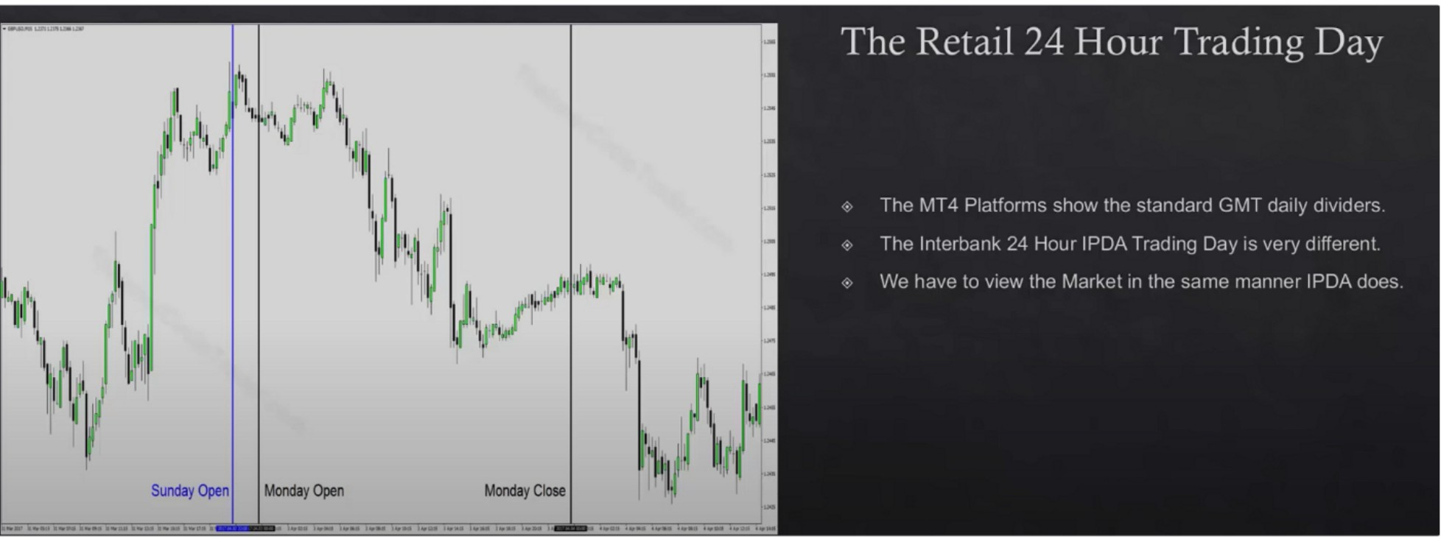

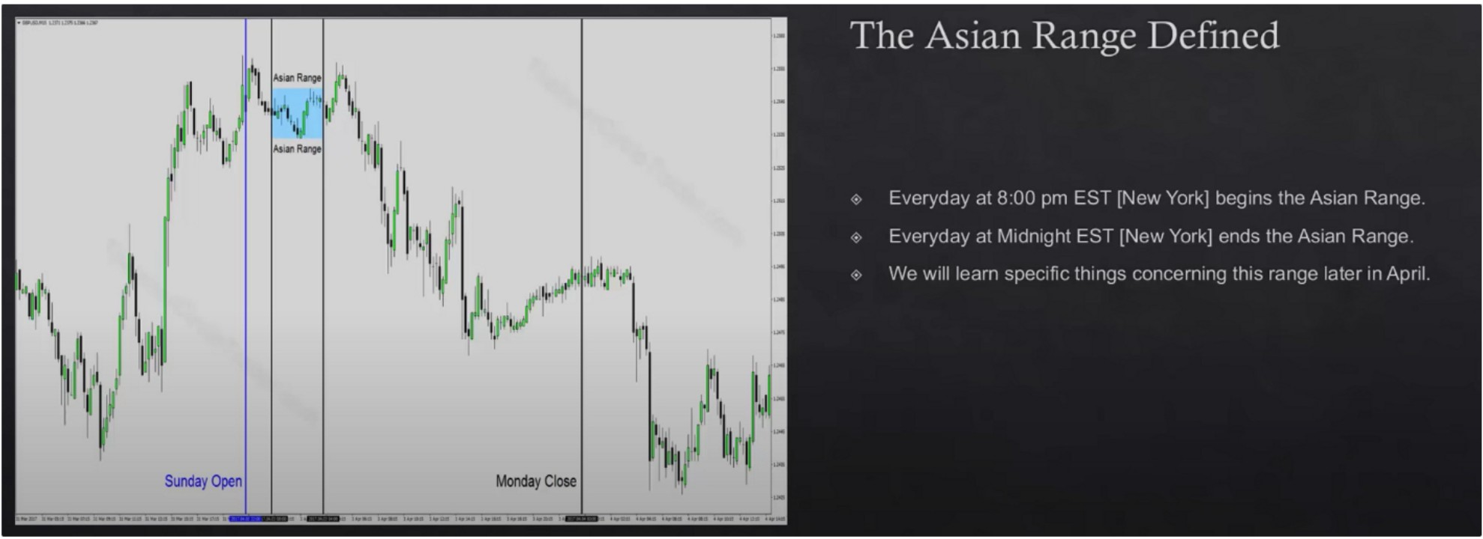

The JCT London Killzone

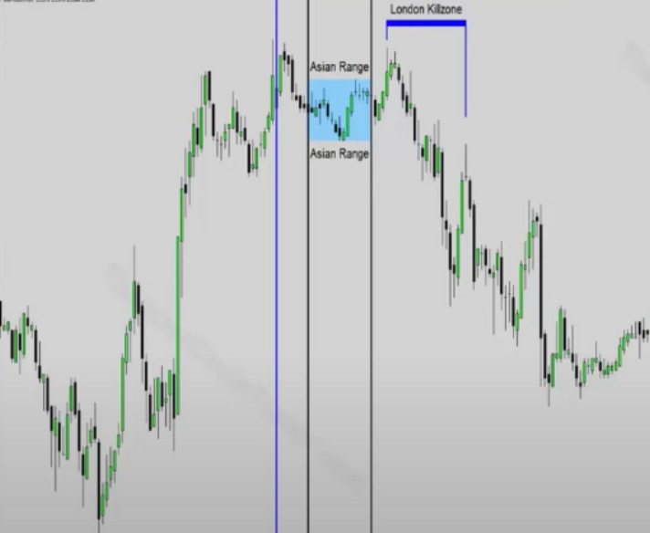

**Sunday Open**

**Monday Clooe**

Everyday di 1 00 am EST [New York] begins tile London K1IILone Everyday al 5 00 am EST [New York] ends the London Klllzone We will lec1rn specific things concerning this KillLone later 1r1 April

The true London open killzone time

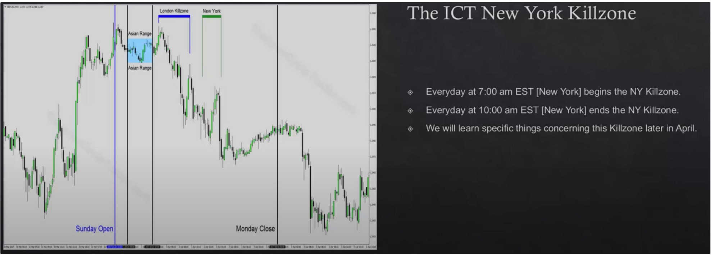

New York killzone time

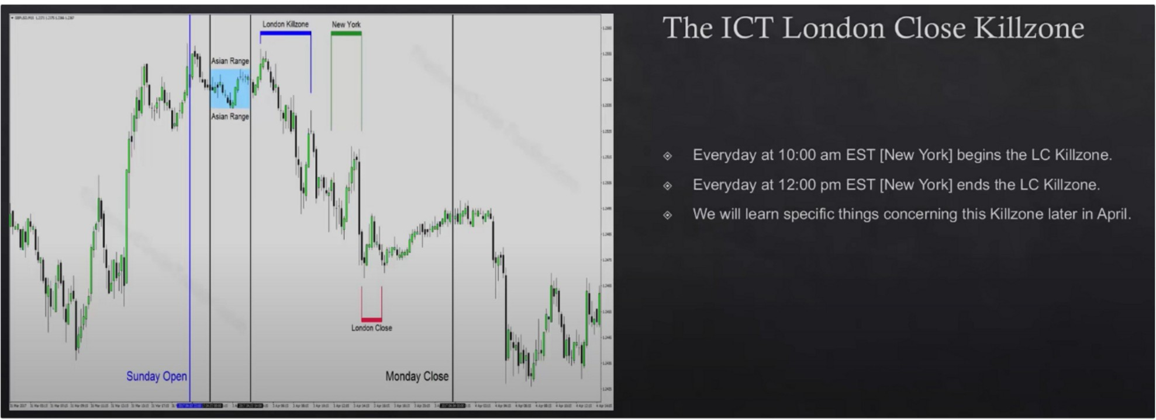

London close killzone time

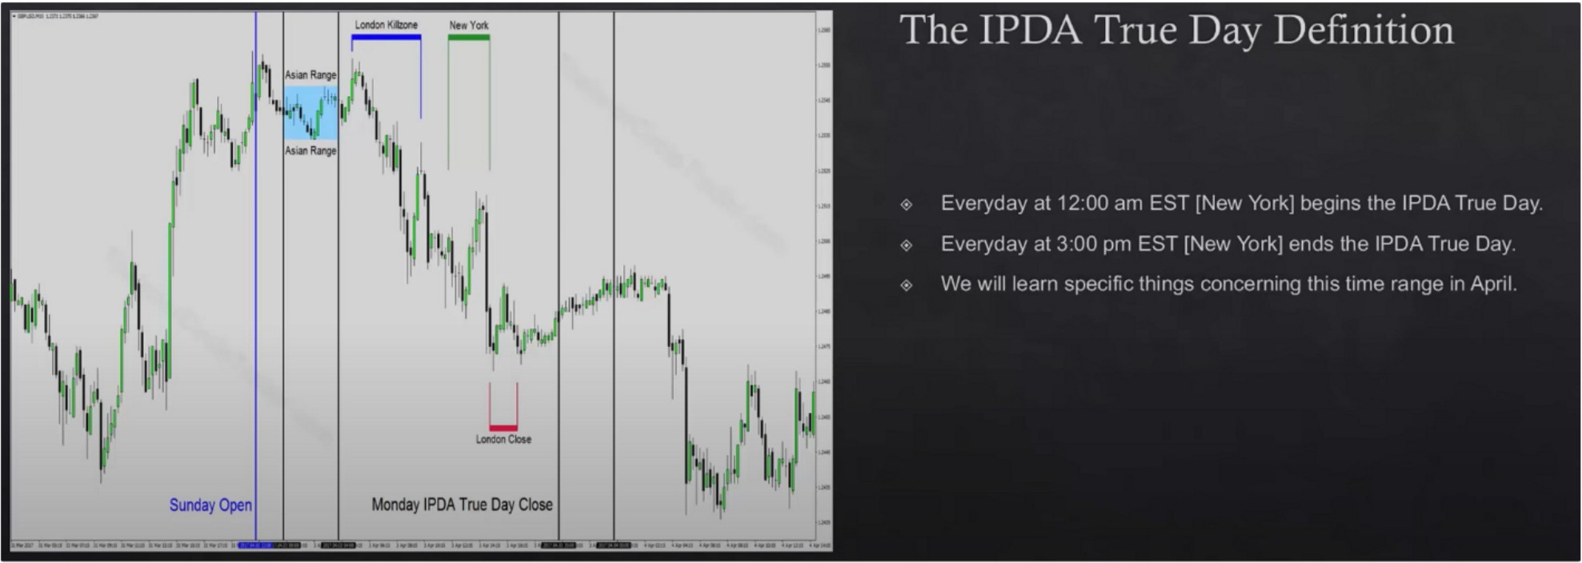

IPDA true day time

|  |
| --- |
| Monday IPDA True Day Open |
|  |
| Monday IPDA True Day Open  8:20 am EST CME Open |

CME open

London lunch, not looking for any major price moves 2pm-3pm is the close, 3pm is the bond close

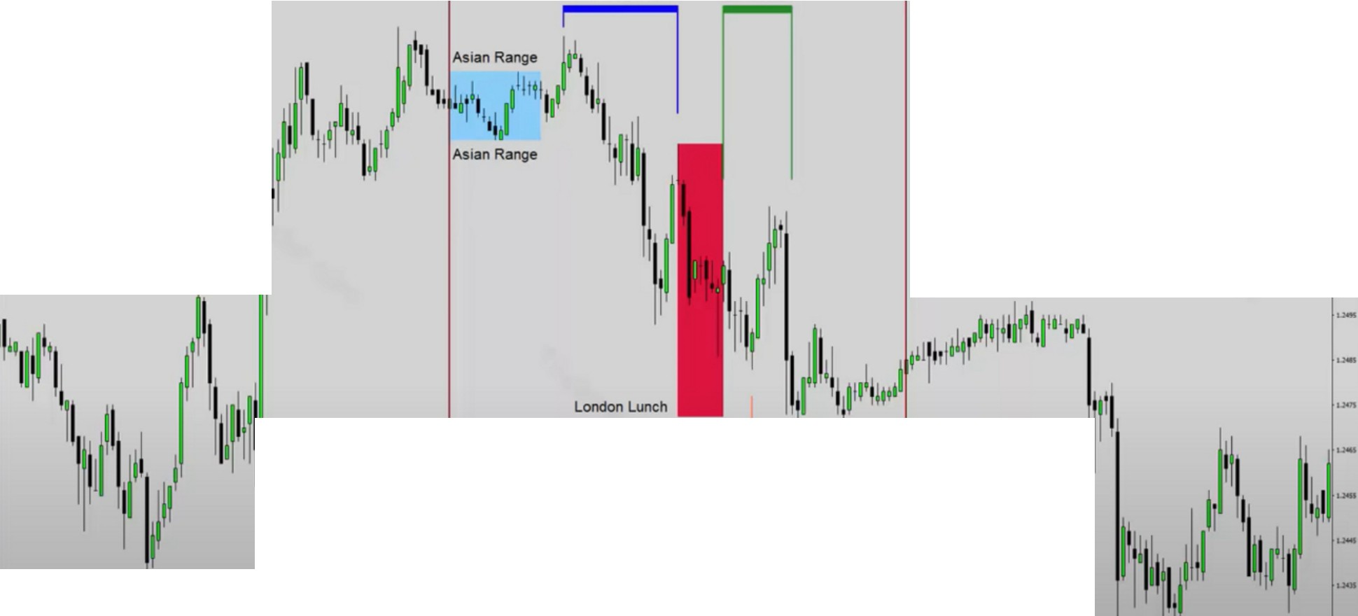

**London K1llmne New York**

**Monday IPDA True Day Close**

**London Close**

LJ

**Monday IPDA True Day Open**

**8:20 am EST CME Open**

No matter what happens at FOMC, the bulk of the move has ended at 3pm

Arjo I Twitter, lnstagram I Linktree

Linktree. Make your link do more. https://t.co/HhmmTN1fUI

JavaScript is not available.

***"JI*** https://twitter.com/arjoio